Assessment: In-Lab 3

Student Name: Enter Yiyang, Xia

Lab Professor Name: Syed Kamran Bilgrami

Lab Section Number: 333

Due Date: 10-30

# Task 1

**Class: Exercise 3**

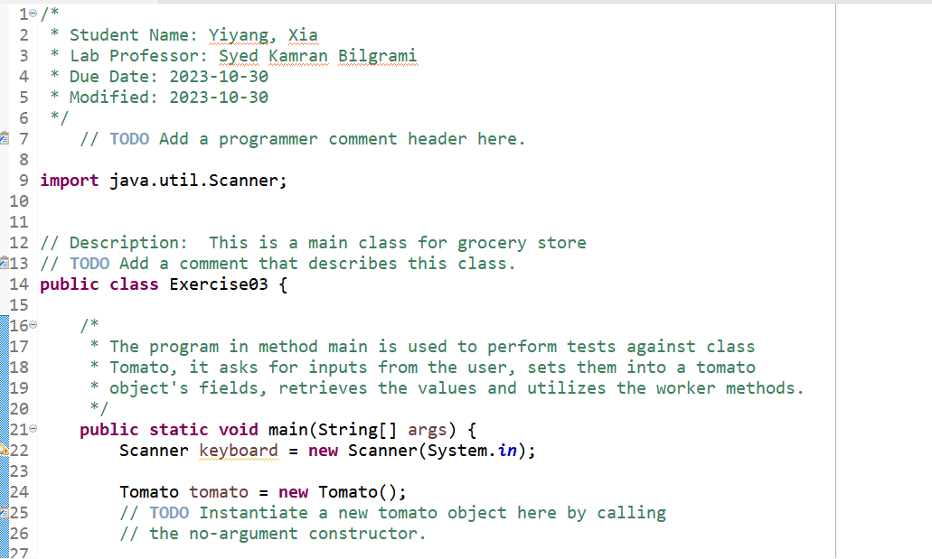

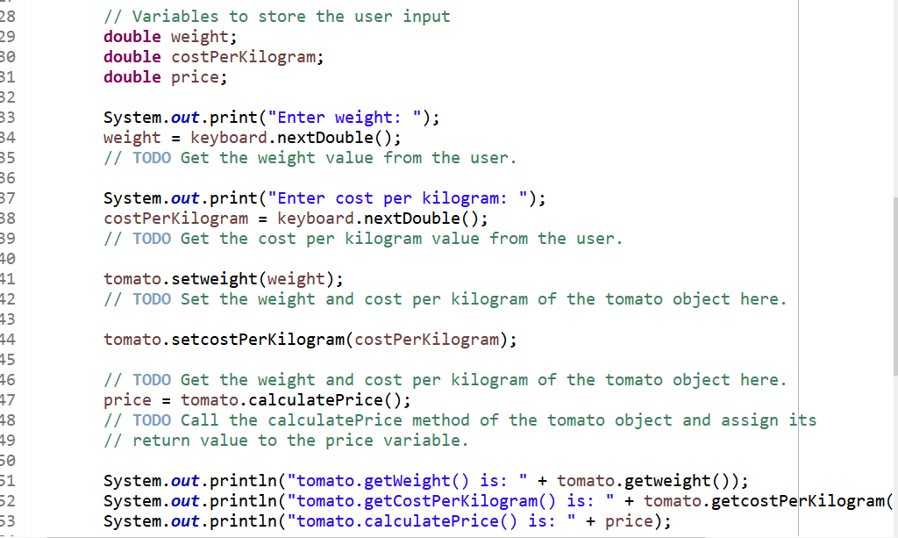

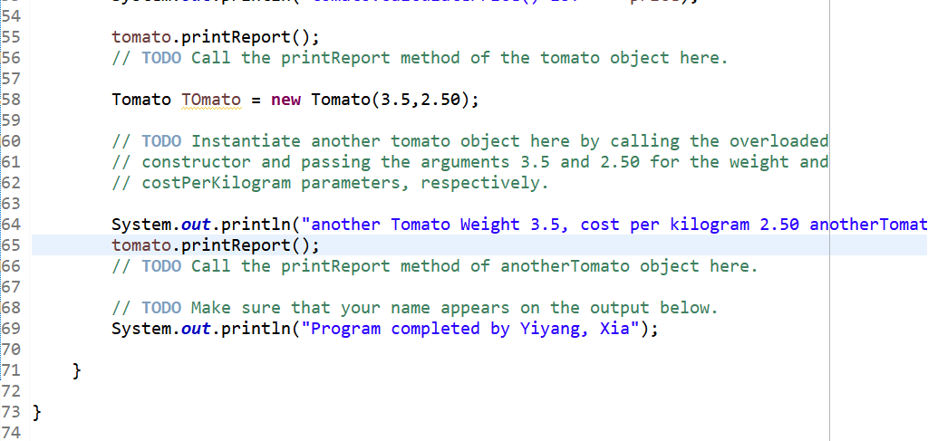

**Class: Tomato:**

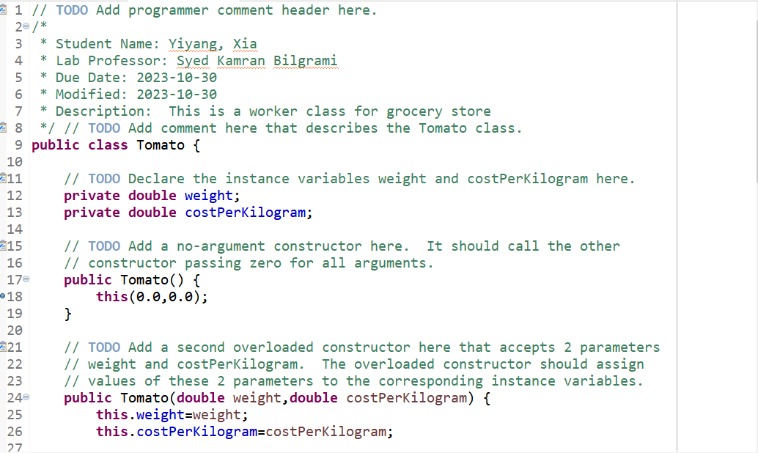

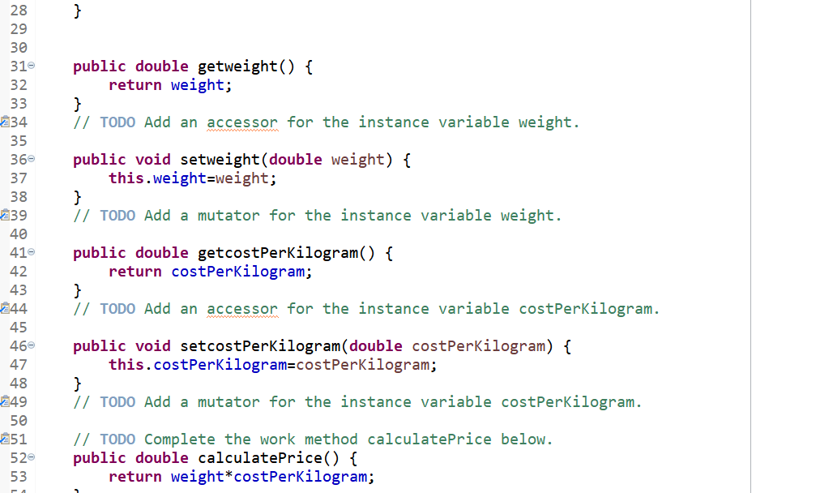

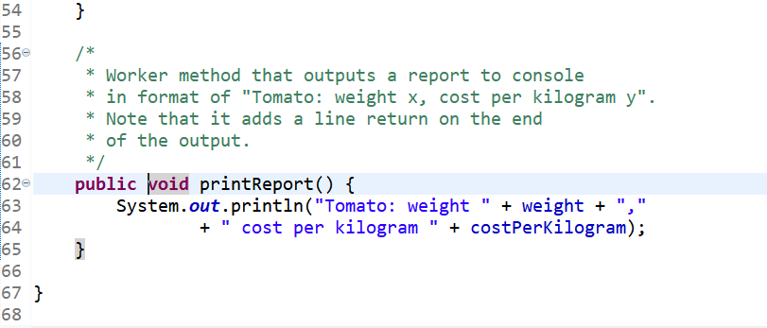

# Task 2

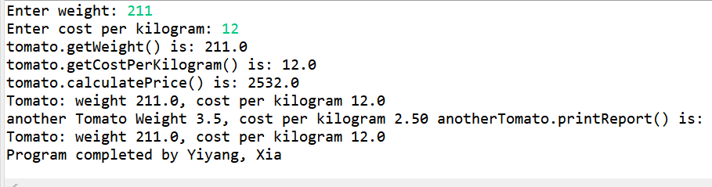

|  |  |  |  |
| --- | --- | --- | --- |
| Input | Expected output | Actual output | Description |
| 12  32 | Enter weight: 12  Enter cost per kilogram: 32  tomato.getWeight() is: 12.0  tomato.getCostPerKilogram() is: 32.0  tomato.calculatePrice() is: 384.0  Tomato: weight 12.0, cost per kilogram 32.0  another Tomato Weight 3.5, cost per kilogram 2.50 anotherTomato.printReport() is:  Tomato: weight 3.5, cost per kilogram 2.5  Program completed by Yiyang, Xia | Enter weight: 12  Enter cost per kilogram: 32  tomato.getWeight() is: 12.0  tomato.getCostPerKilogram() is: 32.0  tomato.calculatePrice() is: 384.0  Tomato: weight 12.0, cost per kilogram 32.0  another Tomato Weight 3.5, cost per kilogram 2.50 anotherTomato.printReport() is:  Tomato: weight 3.5, cost per kilogram 2.5  Program completed by Yiyang, Xia | Java program output matches the expected output. |
| -2.1  1.2 | tomato.getWeight() is: -2.1  tomato.getCostPerKilogram() is: 1.2  tomato.calculatePrice() is: -2.52  Tomato: weight -2.1, cost per kilogram 1.2  another Tomato Weight 3.5, cost per kilogram 2.50 anotherTomato.printReport() is:  Tomato: weight 3.5, cost per kilogram 2.5  Program completed by Yiyang, Xia | tomato.getWeight() is: -2.1  tomato.getCostPerKilogram() is: 1.2  tomato.calculatePrice() is: -2.52  Tomato: weight -2.1, cost per kilogram 1.2  another Tomato Weight 3.5, cost per kilogram 2.50 anotherTomato.printReport() is:  Tomato: weight 3.5, cost per kilogram 2.5  Program completed by Yiyang, Xia | Logic error |
| x  1.2 |  | Exception in thread "main" java.util.InputMismatchException  at java.base/java.util.Scanner.throwFor(Scanner.java:939)  at java.base/java.util.Scanner.next(Scanner.java:1594)  at java.base/java.util.Scanner.nextDouble(Scanner.java:2564)  at Exercise03.main(Exercise03.java:34) | Syntax error |

# References / Sources Cited (optional section as needed)